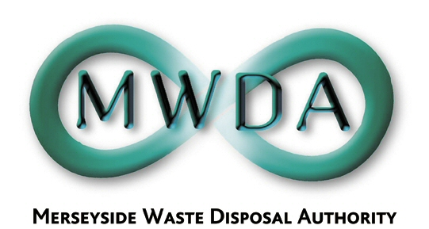

AGENDA

Meeting of the Authority

Friday, 27th November 2009 at 2.00 pm

Venue: Huskisson Room, Millennium House,
Victoria Street, Liverpool

Membership:-Sefton Borough Council: Cllr K Cluskey (Chairperson)
Cllr D Tattersall
Knowsley Borough Council: Cllr D Lonergan
Liverpool City Council: Cllr P Moffatt
Cllr T Moore
Cllr N Mills
St. Helens Borough Council: Cllr D Crowther
Wirral Borough Council: Cllr G Gardiner
Cllr J Salter (Deputy Chair)

Halton Borough Council: Cllr P Harris (Observer Status)

Item No. | Title | Page
1 | Apologies for absence
2 | Minutes of the Annual General Meeting held on 25th September 2009 | 1
3 | Declaration of Interests by Members and Officers | -
4 | Question(s) from Members under Procedural Rule 9 | 7
5 | Question(s) from Members of the Public under Procedural Rule 10 | 9
6 | Motion proposed by Members under Procedural Rule 15 | 11
7 | Authority Representation  WDA/41/09 | 13
8 | Annual Audit Letter  WDA/39/09 | 19
9 | Internal Audit Report  WDA/38/09 | 37
10 | JMWMS Strategy Review Progress Report  WDA/40/09 | 61
11 | International Financial Reporting Standards – Transitional Arrangements (IFRS)  WDA/44/09 | 83
12 | Exclusion of the Public:  Recommendation that the Public be excluded from the meeting during consideration of the following items for the reason stated:-  Items: Reason (under Local Government Act 1972)  13,14,15 Information relating to the financial or  & 16 business affairs of any particular person, including the Authority holding that information (Para 3 of Schedule 12)
13 | Provision of Support Services  WDA/43/09 | 101
14 | Mersey Waste Holdings Limited (MWHL)  WDA/42/09 | 109
15 | Resource Recovery Contract Procurement Project Evaluation of Submission of Detailed Solutions  WDA/46/09 | 179
16 | Resource Recovery Contract and Cost/Risk Assessment of Alternative Solutions  WDA/45/09 | 209

6th Floor, North House, 17 North John Street, Liverpool,Merseyside,L2 5QY
Tel: 0151 255 1444 Fax: 0151 227 1848
Email:enquiries@merseysidewda.gov.uk
www.merseysidewda.gov.uk

